University of Illinois at Urbana-Champaign

PiezSole

BADM 365: New Product Marketing

Creatives Final Report

Melissa Chiou

Owen Jacobs

Venya Joshi

Annabelle Ju

Ananya Kommalapati

Soham Manjrekar

Stratis Papageorgakis

Dev Shah

Monday, December 12, 2022

**Executive Summary**

PiezSole is a novel product for athletes looking to track and analyze data related to their biomechanics. Our product is a shoe insole that is self-charging and collects data on weight distribution, foot position, gait, and stride. We provide comprehensive lower body performance and injury prevention metrics. The industry has an expected compound annual growth rate of 15.5%, and US professional sports organizations are encouraging technology adoption. Analysis of Porter's 5 forces reveals that this is an opportune market for new entrants. Primary and secondary research also determined that there is value in targeting professional athletes and training staff as our purchasers. Our market is saturated with big players like Catapult Sports and Zebra Technologies, but the greatest potential threats come from our major product form and category competitors; Plantiga, Jogo, and Nextiles. However, Piezsole has a differentiated competitive advantage as the only product available with injury *prevention* technologies. A multi pronged promotional approach builds and maintains credibility, through emotional and rational appeals. The segmentation analysis revealed that the target segmentation is 16-20 years old, all genders, occupations that require peak athleticism, individuals that lead healthy, active lifestyles, and are seeking methods to optimize their physical performance. Comparing the military, medical, and sports industries reveals that sports is the only valid target market as it is measurable, reachable, sizable, coherent and manageable. We will position Piezsole around the injury-prevention technologies the product has, emphasizing its performance maximizing abilities. Our marketing mix uses prestige pricing, direct-to-consumer distribution, traditional and non-traditional promotion tactics, and a comprehensive roll out plan to appeal to customers and ensure long term success. Piezsole seeks a $3 million dollar investment to bring our product to market. Under some assumptions, it was found that our company could generate roughly $3.9 million in revenue and $1.4 million in profits over a 5 year period.

**Product Description & Competitive Set:**

The PiezSole is a device packaged in a shoe insole targeted towards athletes who wish to detect and analyze data related to their biomechanics. This product implements piezoelectric generators where mechanical energy in the form of footsteps is converted to electrical energy to power PiezSole. A normal footstep generates up to 7 watts of power which is more than enough to power the device’s circuit board and sensors. Thus, through the act of walking or running, PiezSole will always be powered on. A supercapacitor is also utilized to store excess energy which could power the device during inactivity. The product has five distinct sensors used to collect biomechanical data. First, pressure sensors measure weight distribution over your foot. This data can be used to determine how a user walks or runs and can help prevent injury by providing feedback to the user regarding how they could improve the composition of their step ie. heel-toe vs toe-heel. Next, accelerometers are used to track foot position and measure the user’s gait and stride. These can be used to measure balance, stability, and (in conjunction with the pressure sensors) overall output force of the user. Third, the onboard RFID chip tracks the user's overall displacement during utilization. Tracking an athlete’s precise location on the field can improve individual development in field positioning and other useful metrics. Additionally, textile electrodes measure muscle tension through analyzing when muscles tense and relax, and can be used to predict or prevent a muscle cramp. PiezSole relays the data collected with a bluetooth transmitter from the insole of the shoe to an external app or software depending on where the user would like to view the data. The software utilizes artificial intelligence to inform users of potential risk-of-injury based on known patterns, tendencies, and analytics.

The technology goals for PiezSole are feasible. To keep the pliability of standard shoe insoles, PiezSole uses flexible circuit boards which can adapt to the motions of a foot. Standard insoles which athletes wear can range anywhere from 3 mm to 10mm thick meaning that there is room inside of the insole for technology to be inserted. Current flexible circuit boards can range anywhere from 0.22 mm for 1 copper layer to 0.42 mm for 4 copper layers meaning that they would be able to fit inside. Not to mention, they are waterproof which is vital to prevent sweat damage. The piezoelectric generator which would be utilized for PiezSole is, at most, 1 mm thick. For our purpose, a supercapacitor is capable of being smaller than 1 mm. Similarly, pressure sensors, accelerometers, RFID modules, and textile sensors are all near 1mm thick or smaller meaning that they could be stacked on top of each other while still fitting in a normal-sized insole.

The current solutions for athletic organizations to professionally track and measure an athlete’s podiatry involve buying and renting expensive equipment or contracting external companies and scheduling appointments with physical therapists or similar medical professionals to undergo various tests. The major drawbacks with both of these solutions are time, money, accessibility, and relevance. On top of spending money on professionals and time at exams or appointments, consumers do NOT get immediate access to their results and the results they get are NOT from “on-field play” when athletes are naturally in motion. Our solution gives athletes their data in real-time, does not require batteries or external power sources, comes in an unobtrusive package, and, most importantly, provides vital injury prevention feedback.

**Industry Analysis**

The fitness tracker industry encompasses products tasked with recording and providing consumers convenient access to their own fitness data. In the modern day, the market is dominated by common names like Apple, Samsung, and Fitbit. These companies market fitness tracking products to be worn around the wrist, which are bundled with the functionality of a smart device. A majority of players in this industry are creating products for every day individuals to track their activity; however a few lesser known names are catering to a sub-market of higher-demanding upper level athletes and professionals: Zebra, Catapult, Jogo, Plantiga, and Nextile.

As of 2021, the fitness tracker market size was estimated to be $45 billion with the largest market share being held by the United States. From 2022 to 2030, it is estimated that the U.S. market for fitness trackers will grow at a compound annual growth rate of 15.5% (Straits Research). In recent years, the growth potential of the fitness tracker industry in professional sports is evident. In 2014, the NFL signed a contract with Zebra to integrate RFID tracking devices into player equipment. Various NBA teams have adopted Catapult’s advanced cardiovascular and respiratory fitness trackers. The NHL began integrating player and puck tracking ensuing technological testing in 2020. The MLB approved the use of advanced activity trackers circa 2017.

There are a handful of factors which can influence the future growth of this industry within high level sports. Primarily, governing bodies of sports organizations can regulate technologies which can be used in training and during game play. Leaders in said organizations – notably Adam Silver, commissioner of the NBA, and NFL operations – have emphasized the importance of integrating technology in their sports with a primary focus on improving player availability. This gives the indication that large level organizations are seeking technology which fulfills these tasks. Moreover, the pandemic enabled coaches to realize the importance of gathering fitness metrics, especially when they may not be in the same geographical location as their athlete. Lastly, macroeconomic factors are unlikely to have an appreciable effect on this industry as high level sports organizations operate with massive budgets, and their revenue streams are projected to continue growing.

To determine how PiezSole plans on positioning itself in the market, we made use of Porter’s 5 Forces (Appendix 3.1). First, the growing nature of the fitness tracker industry (15.5% CAGR), especially with the pandemic highlighting its importance, suggests an increased risk of new entrants. Moving forward, there are many small-scale players competing in their own niche and aiming to intrigue different customer segments, thus enjoying limited competition. Next, market players are catering to different customer needs thereby lowering the bargaining power of buyers as there are few alternatives and products have different capabilities. Within the limited number of players in the market, Jogo and Plantiga are our prime competitors (product form competition). However, their product capabilities and target audiences vary. Finally, the bargaining power of suppliers is unlikely to play a considerable role in the market at the present moment as primary components used in PiezSole, including five major sensors, a super-capacitor, and the physical insole, are individually mass-produced items, rendering them widely and easily available. Overall, PiezSole will position itself in this growing market by leveraging the currently low threat of substitution. This will be made possible by marketing a product that combines the functionality of those available, and offering new features, at a competitive price.

**Competitor Analysis**

*Understanding Competitors*

In Budget-Dollar Competition, products and services related to athletic performance compete for the same customer dollar. PiezSole competes with companies like Amazon, Next-gen Stats, and Kinexeon. Currently partnered with the NFL, Next-gen stats uses AWS to collect real-time location data that captures the activity of every player in every play. Kinexion, also in various partnerships with athletic organizations, produces easily concealable pucks that measure centimeter accurate position and performance data.

In Generic Competition, we included products that address the same need as ours, which is any wearable device for the purpose of data collection. Piezsole competes with companies like Zebra Technologies, STATSports, Catapult Sports, WHOOP, Oura Ring, Zephyr Performance Systems, and Motus. Many of these generic competition companies have contracts with the NFL, NBA, FIFA/MLS, and MLB.

In Product Category Competition, we include any products and services that fall under lower body wearable devices for athletic data collection. Companies like Nextiles and STRIVE, currently partnered with the NBA, both have products in sensor fabrics. Nextiles, for instance, specializes in sensor-embedded clothing that measures an athlete’s performance across their entire body. In addition, this competition level includes companies like Footbar, which produces calf sensors, and WHOOP body.

Finally, the main players in Product Form Competition include Plantiga and Jogo. Plantiga creates sensor insoles that track gait and biomechanics. Similarly, Jogo focuses more on the soccer industry with a similar sensor insole.

*Competitive Advantage*

PiezSole’s current main potential threats include Plantiga and Jogo in product form competition as well as Nextiles in product category competition. Firstly, Plantiga is a relatively small company with impressive ability in product conception and design. The company has a sophisticated technological strategy for their insole sensor, which is small and durable as well as water and impact resistant. It carries features like a six-axis inertial measurement unit and 416 Hz sampling rate. As a startup product, Plantiga drew on the expertise of its founding members Lauren Friedman, Megan Jones (PhD), and Matt Jordan (PhD), all of whom have combined extensive expertise in physiology and biomedical engineering. Financially, Plantiga has been successful in securing funding through multiple seed and venture rounds, amounting to around $1.5 million total. The company has successfully marketed their device to multiple sports leagues in addition to other institutions. Plantiga’s pricing is currently a one-time insole purchase in the realm of $200 and an $18 per month subscription. Plantiga’s positioning in the market emphasizes its utilization for improving athlete performance as well as better health.

Jogo is a newer company founded around two years ago that produces insole sensor devices. These devices are designed specifically for improving soccer players’ performance. Its product design is centered around tracking data such as distance ran and ball touches. The sensor is waterproof and lightweight, capable of 100 Hz data sampling. Founded by David Dwinger, a veteran in the tech startup space in the Netherlands, Jogo also has strong management ability. In terms of finances, the company was able to acquire a total of around $1.8 million in funding. On the other hand, Jogo does not have significant market presence or marketing ability. Jogo positions itself as a device primarily used for improving athlete skills rather than health and injury rehabilitation.

Finally, Nextiles is likely the competitor with the greatest competitive advantage. Their primary product is sensor-technology woven into fabrics. The company has demonstrated considerable ability in product design, using sophisticated circuitry capable of being stitched into basic threads like cotton and polyester. The company’s core team includes George Sun, John Peters, Matt Evans, Eric Chan, and Robert Lindo whose collective expertise ranges from MIT bioengineering to textile engineering. This executive team also appears to have extremely capable management ability, many of them having previous experience as CEOs or founders of other projects. Financially, Nextiles has the most funding of the three companies, acquiring a total of around $5.3 million, which enables them significant opportunity and flexibility for production and development. In regards to marketing ability, Nextiles has been extremely successful in promotions, both through social media as well as events like NBA Launchpad. Like Plantiga, Nextiles’ versatility in both improving athlete performance and in injury rehabilitation is a major factor in its current success and market advantage.

*Leveraging*

Based on the competitive landscape of the fitness tracker industry and the direct competition that PiezSole faces, there are clear and present business opportunities that can be leveraged by PiezSole to achieve success in the marketplace. First, competitor brands in the market have been able to successfully secure funding by orienting their marketing to emphasize player recovery and injury rehabilitation. This positioning has a proven track record of success, and there is clear demand for such products as indicated throughout the pro-sports industry. The high priority of this unmet need has been reinforced by monetary investment through the NBA’s Launchpad program segment, which is focused on soft-tissue injury prevention and recovery as well as the NFL’s $4 million investment into research to better understand and prevent lower-extremity injuries (Maaddi). To seize this opportunity PiezSole can follow the lead of its competitors and focus its marketing strategy and branding on improving player health to keep players on the court for longer while performing at a higher level.

Alongside leveraging existing successful market strategies utilized by competitors, PiezSole’s unique competitive advantage distinguishes it from the competition and sets it a step above in the marketplace. PiezSole’s competitive advantage is two-fold, the product offering requires the least change in current consumer behavior of any product form or product category competitors in the market and is the only product available with injury *prevention* technologies. First, PiezSole never needs to be charged, creating a seamless “plug and play” user experience in comparison to competitors’ products being limited by battery. PiezSole technology allows for users to gain technical data on their workouts for as long as they’d like instead of as long as they have charge. PiezSole’s injury preventiontechnology holds an even greater competitive advantage in the marketplace, as it addresses a current market gap. Injury preventiontechnology is not prevalent in the marketplace, injury rehabilitation technology is. PiezSole uses a predictive algorithm to alert users to actions and tendencies that increase risk of injury. This is a clear advantage over all current competitors as it helps stop injuries before they happen, which keeps players on the field as much as possible.

**Customer Analysis**

*Buyers Versus Users*

PiezSole (PS) distinguishes themself in the athletic footwear industry by its application in sports and high-intensity athletics. In order to determine PS’s customer orientation, it is necessary to discern who is involved in the roles before, during, and after. Initially, coaches and physical therapists will point out a player’s poor mechanics through movement analysis, which results in temporary biomechanical solutions. However, when athletes perform with the necessary complex movements in play, especially for reactive sports, vision and game tape are often not precise enough to identify faults in technique. According to the Sports Medicine Journal, “coaches are interested in technical and health-related metrics'' (SMJ), but the ability to track these criteria is tedious and unattainable without a technology implemented resource. Professional University sports teams typically employ Athletic Equipment Managers (AEM), where job descriptions of Equipment Operation include purchasing and ordering uniforms and equipment (Markus), which would indicate that the buyers of PS in professional athletics would be managers. The end-user would be the athlete or individual who is using the insole and data it produced. A study done at the Department of Musculoskeletal Disorders, School of Medicine and Surgery University of Salerno determined that in regard to injury prevention studies, athletes are “afraid of losing their place in the team due to the highly competitive scenario and naturally come under higher pressures to return to play,” alluding to a desire for injury prevention to be prioritized during training sessions.

*Primary Research*

Our initial survey was distributed amongst every demographic at random, where we measured age, gender, and lifestyle. The questions on the survey were largely quantitative (numerically rated items, true and false questions, and quantified daily observations). We drew our data from a sample of 30 college students aged 18-23 years old at UIUC. We surveyed college students as they tend to be an active population.

We found that 83.3% of subjects stated that they exercised, on average, between 0-60 minutes a day, which we do not classify as a high athletic measure, however a narrow majority of 56.7% owned some form of a fitness tracker, with a 60% overlap of the two attributes. That data, vacuously, challenges our initial hypothesis of marketing to high-level athletes; however, when subjects were asked to rank factors of shoe products based on importance, personalized features–which includes personal fitness tracking–was ranked as least important (lowest and second lowest ranks) by 90% of respondents, which corroborates the lack of importance sports technology plays in the lives of non-athletes. While we cannot speak for the 40% of respondents who use a fitness tracker in their daily lives, the 60% who do not, also had a large overlap with ranking personalized features as their lowest attribute. On the other hand, injury and cramp prevention, battery-less use, and gait and stride tracking were the top three features that respondents indicated as the highest level of usefulness. Thus, giving us the data that we should focus on the development and marketing of those three compared to the other features.

**Marketing Strategy**

*Market Segmentation*

To delve deeper into the type of customer that PiezSole should be sold to, a market segmentation analysis will be conducted. Our target market will have a demographic of ages 16-40 years old, as that appears to be the age range where people are more serious about their physical activity. More specifically, young adolescents typically begin their fitness training with more thorough goals, perhaps to win state championships or get recruited for the collegiate level, around 16 years old. Although the analysis is still from a broad perspective and not focusing on just athletes, it is worthy to note that this lower end of the spectrum was selected partially due to the fact that some professional soccer players are as young as 16 years old. On the other side of the spectrum, adults whose athletic performance would matter for their profession would likely cease to need the optimization tools as they age past 40 years. In the gender category, PiezSole will be marketed to all genders because after thinking through the uses and benefits of the product, there is no apparent factor that would make it more relevant to one particular gender over another. Additionally, the customer segment’s occupation should require excellent athletic performance as the Piezsole is an in-depth analysis tool that would be most applicable to people whose livelihoods depend on their athletic ability. From a psychographic standpoint, we are looking at individuals who value their health and athletic performance. They should lead active and health conscious lifestyles as well as have self-driven, goal-oriented mentalities. Behavior wise, our consumers would be people who are seeking methods for injury prevention and performance analysis on an everyday basis. So this would narrow our customer segment down to a more niche group of people, not the general public. We are confident that the loyalty to PiezSole will be consistently high. Our brand is worth sticking with because in addition to the groundbreaking innovation of our product, we provide better functionality for the same price, which results in better value. Lastly, our geographic scope will be global, as there are people of this description all over the world, but our company will be based in the United States.

*Target Market*

Based on our segmentation, PiezSole could be a valuable tool for many industries, such as the military, sports, and medical fields. In the military, the PiezSole's ability to track and analyze data could be used to improve the performance and reduce the risk of injury in soldiers. PiezSole could also help soldiers maintain proper posture and gait during training and combat operations, leading to improved efficiency and effectiveness. In the sports industry, the insights provided by the insole could help athletes optimize their foot striking, balance, and pressure distribution, leading to improved speed, agility, and endurance. PiezSole could also be used by coaches and trainers to monitor and assess their athletes' biomechanics, to tailor their training programs and prevent injuries. In the medical field, the PiezSole could be used by patients and healthcare professionals to diagnose and treat a variety of conditions related to the foot and lower body. The data and insights provided by the insole could be used to identify imbalances and abnormalities in a person, leading to more effective treatment and rehabilitation. PiezSole could also be used by physical therapists and other rehabilitation specialists to monitor a patient's progress and adjust their treatment plan accordingly.

We will conduct a thorough evaluation to assess whether or not each market is measurable, reachable, sizable, coherent, and manageable. The military is a multi-trillion dollar industry and invests nearly $2 billion annually on training/performance tracking equipment. However, it is not necessarily reachable, most of the military’s spending in this specific segment is reserved for research in performance augmenting technologies. Additionally, there aren't many established channels for promoting and distributing PiezSole into the military market. This market is sizable, since this market is expected to grow to $4 billion by 2025. This market is also coherent, as our typical customers are military personnel who have similar training and physical demands. This market may not be manageable for an emerging business, as dealing with the military can be complex and may require specialized knowledge and expertise. The medical industry, like the military industry, is a multi-trillion dollar industry, the physical therapy and injury prevention segment of the market makes ~$4 billion annually. It’s reachable, as 90% of physical therapy patients are looking for injury prevention/mediation, and there are established networks for promoting and distributing new products. This market is sizable as well, the physical therapy (PT) segment is expected to grow to $5 billion by 2025. It’s coherent as well, since we can take patients looking for podiatry solutions as our typical customer. However, this market is not manageable. There are nearly 40,000 PT clinics in the US, and less than 10% of all visits to physical therapists are for podiatry related issues. This is an obstacle for PiezSole and would require a great deal of investment to garner a significant portion of this spread out market to become profitable. The sports industry is measurable in terms of purchasing power and size, as athletes and sports teams have budgets for purchasing equipment and there are a significant number of athletes and teams. Sports organizations spend upwards of $12 billion dollars annually on performance tracking technology, more than both the medical and military industries combined. It is reachable, as we explored in our interim report the sports industry has established networks for promoting products like PiezSole in the form of NFL Innovation and NBA Launchpad. It’s sizable, as the sports industry is expected to grow to $15 billion by the year 2025. It’s coherent, with athletes as our typical customer. It’s also manageable for PiezSole, since there are less than 200 professional sports teams in the US, and each team is user dense. This allows PiezSole to sell many units even if we are providing support to only a few teams.

The military and medical industries may be effective markets, but may require more specialized knowledge and expertise to serve. As a result, the sports industry is the most effective target market for PiezSole, as it meets all of our established qualifications.

*Positioning*

With our target market in hand, the focus of our marketing strategy shifts to how Piezsole will look to be positioned. Looking at the bigger picture of the sports industry, the primary focus of most wearable fitness tracking products is **injury recovery** and performance tracking. As a result, this sector of the market is well-catered to and saturated with a variety of different offerings. These products are only differentiated by the specific performance metrics they analyze and many of these products have a high degree of overlapping features and uses.

Piezsole lies in a unique untapped segment of today’s existing wearable fitness sports industry. Most fitness trackers on the market are focused on cardiovascular tracking and higher-level overviews of athletic performance and health. Piezsole offers users two key differentiations from the majority of fitness trackers with its specific focus on in-depth lower extremity tracking and **injury prevention** technologies. We plan to leverage these two key product features to develop Piezsole's positioning in the market and shape how our product is perceived by consumers.

We plan to present our product’s lower extremity injury prevention technologies and ‘high-risk of injury action’ notifications at the forefront of our marketing to consumers, with the goal of driving home the injury-reducing value that Piezsole uniquely has. We want Piezsole to occupy a space in consumers’ minds that represents performance maximization and recovery/rehabilitation time minimization. Consumers should feel empowered with Piezsole, knowing that with our product they can get in-depth consistent feedback on their athletic performance. Piezsole allows consumers to know exactly what they need to improve their quality of play while helping them prevent injuries, helping them stay in the game for longer. We want to position our product in such a way that our injury prevention technologies are considered just as essential to athletes as stretching before their workouts. At Piezsole it is our goal to become a key part of athletes’ training processes, making them feel safe and protected with our product.

**Marketing Mix and Implementation**

*Pricing Strategy and Tactics*

In terms of pricing strategy, we will pursue an objective of sales maximization, which focuses on generating as much revenue as possible. As a new company, the best course of action is to prioritize establishing our consumer base. Our customer demand is relatively inelastic considering the importance of athlete injury prevention to our target market. Although athletic trackers are considered non-essential, professional and collegiate sports leagues are increasingly emphasizing the significance of athlete health; Piezsole would be a long term investment to address this issue. For estimated costs, our fixed costs will total around $500K **(see financial analysis)**. In regards to competitor prices, the most concrete data we can acquire is from Plantiga, which offers insoles at $200 with a $30 per month subscription fee. Jogo offers a freemium model with base features and a €10 per month starting price for premium and other offers. Finally, Nextiles has no publicly available pricing information; their price points are dependent on use case. In consideration of these competitor offers in addition to the value added from the Piezsole product, we ultimately employ prestige pricing as our pricing strategy.

Piezsole has different rates for our presell period versus our final retail price. In addition, we price Piezsole differently for bulk orders (fifteen insole pairs or more) and individual (single sales). For bulk orders, the software subscription cost does not change with increased units, which will encourage organizations to purchase more units. Our insoles retail for a higher price point than other similar wearables to reflect the significant added value that Piezsole’s metrics, self-charging, and other unique capabilities bring. In addition, the injury prevention data and algorithms that come with the software subscription make it a valuable service that other competitors fail to deliver; our subscription service is priced around 30%-50% higher than our competitors. Refer to Appendix Figure 4.1 for details on pricing.

*Channel Strategy and Tactics*

For our channel strategy, we will structure it to begin with the manufacturer and then directly reach out to sports teams—they would be the purchasers for the end-users who are the athletes. We can also connect with professional sports teams as well as collegiate level teams who are interested and sell them our product in bulk orders by contract. Once we are more stable in the market, we can ease the process by also selling the product through our online platforms to athletes that might not necessarily be part of the teams we initially target. Making use of the above distribution channel would increase efficiency, allow Piezsole to delineate work to the manufacturer, while also developing a valuable network for future needs. It should also be noted that the pricing strategy has a direct impact on the manufacturer level of the channel strategy due to the bulk-order versus individual pricing. Our channel strategy is set-up to allow our product to successfully reach consumers and can be modified for market and demand changes.

*Promotion Strategy and Tactics*

Piezsole makes use of integrated marketing communications to convey a coherent message about our brand to our market segment. Our product concept is relatively new to the market, thus our promotional efforts focus on pioneering and persuading consumers of our brand and product. As we are aiming to sell to athletic leagues and larger sports organizations, we must emphasize trust and highlight the value in injury prevention that we bring to those parties.

Piezsole will leverage personal selling as our most impactful strategy. Our company will keep consistent communication with athletic staff to effectively introduce the product and clarify any doubts. We will highlight our injury prevention value and illustrate the potential improvements in finance and performance. This personal support from Piezsole’s brand is vital as these relationships will develop a network of collegiate and professional athletic staff, which will also produce crucial word-of-mouth promotion. The ultimate goal of personal selling would be to bolster awareness, capture a larger market share, and maximize stakeholder value.

Incorporating traditional marketing tactics will also help maintain our credibility and build a bigger name in the industry. This includes high quality videos and programmatic ads centered on athletic endorsements. Brand ambassadors can bring their unique strengths to the Piezsole brand. Creating an image centered around the individuals we target as users allows us to ignite passion within our brand. Piezsole wants to tell the human story, and our athletes’ journeys drive home those diversified walks of life.

Public relations are also a method we will pursue. Our company’s public interactions will include the owners of leagues, collegiate coaches and sponsors, athletes, and other stakeholders. We hope to build these relations through events such as press conferences, annual reports, sponsorships of sports events, and sports publications. Having a relation from the industry that highlights us in certain publications could launch our brand opportunities and provide added value in the form of brand elevation and visibility.

We want to be part of the human journey. Using emotional and rational appeals allows us to broaden our horizon, drive conversation amongst new audiences, and create connections with our existing audience, which renders the impact of our promotional efforts invaluable.

*Implementation and Roll-Out Plan*

We plan to begin promoting the product on a quarterly basis: For the first quarter, our focus is on creating buzz. Most resources will be invested in promotion and extra market research. We plan to initially test market our product to gain a better understanding of our performance, garner presales on our website, and personally reach out to athletic staff. Additionally, we want to kick off our storytelling to establish our human-centric brand and create a relationship with the sports industry to position ourselves as a quality, high end brand. In the second quarter, we focus on distribution. We plan to explore new avenues of capital by obtaining sponsorships, entering in funding competitions, and attending entrepreneurship events. During this period we will maintain our media presence, including efforts such as engaging with sports publications. Our third quarter is centered on growth. Our goal here follows the AIDA model. We aim to have acquired significant awareness and interest. We also expect to see more desire and action with product orders and purchases beginning to ramp up. We will gather feedback for improvements to use for potential complementary products or extensions of Piezsole. Finally, our last quarter focuses on expansion. We plan to add intermediaries, contingent on product demand. We will also expand on manufacturing and production to bolster our supply chain as well as increase efforts in research and development for complementary goods and improvements. We also plan to continue exploring funding opportunities and work with investors. These goals will ensure that Piezsole continues to stay successful long term.

**Financial Analysis**

Startup funding can occur by various mechanisms. In practice, a ‘typical’ progression could occur as follows: pre-seed capital or bootstrapping, seed funding, series A funding, series B funding, and so forth. Assuming PiezSole can obtain pre seed funding in order to cover costs associated with early business, promotional, and legal operations, seed funding becomes the capital source which will allow the company to bring the PiezSole to market.

Data on early funding for two companies in the same market shows that Plantiga obtained $1.5M in funding, while Nextiles obtained $5.3M. Having demonstrated PiezSole’s feasibility and novelty, along with a sound plan in terms of marketing strategy and mix, it is feasible for PiezSole to seek seed funding totalling $3M. As previously mentioned, fixed costs will total to $500,000 annually. This number is based on two factors; first, Piezsole plans to manufacture the product in-house meaning that $410,000 a year will go to research and development, salaries, renting/leasing a warehouse, etc. The other $90,000 a year will go towards an aggressive annual marketing budget as Piezsole is focused on expanding brand image and trust.

In terms of variable costs to create the Piezsole, the bill of materials comes out to $38.75 a unit (**appendix 4.3**). There are overhead costs that must be taken into account with the manufacturing process, and these costs are estimated to be around $5 a unit. Next, there are distribution costs at $5 a unit as well. Finally, other expenses and overheads which will cover all other possible costs of creating and shipping a Piezsole will be $24.75 a unit. By adding up all the variable costs, it can be concluded that the estimated cost of producing one unit is $73.50. For the pre-sale option where we assume the bulk price for the first 15 units to be sold at $260 per unit and subscription price of $36/month, a margin of 71.73% on each upfront sale is observed **(appendix 4.1, 4.2)**. Assuming a 5 year customer lifetime and using the pre-sale pricing, it can be calculated using the basic break-even point formula that 1065 units must be sold over this 5 year period to recover fixed and variable costs associated with business operations and unit production.

With a sound value proposition, potential investors may be interested in early financial projections. Primary data obtained through convenience sampling of UIUC students indicates that 26.7% of individuals would definitely purchase PiezSole while 13.3% would probably purchase the product **(appendix 2.8)**. The professional sports market, globally, is extremely sizable. The International Olympic Committee estimates that there are ~8 million professional athletes across the globe. However, by solely looking at the NFL, NBA, MLB, and top 5 European Soccer Leagues, there are 5,480 athletes in total. Assuming that there is a market capture of 40% based on the primary data obtained, it can be concluded that there will be 2192 sales. However, people overestimate on surveys leading to inaccuracies. Thus, if Piezsole only assumes a market capture of 30%, there would still be 1644 sales which is 579 sales above the necessary break-even point. These sales are also only considering a small fraction of athletes compared to how many there really are..

In terms of the 5 year projection of Piezsole for revenue and profit, the financial analysis shows that the company would do quite well. By looking at the presale pricing for a bulk purchase with the first 15 units, and assuming that there are 1644 sales to be made at a 30% market capture with a 5 year customer lifetime, the revenue generated by the company would be $3,856,824. In terms of profit, Piezsole would generate $1,357,646 in 5 years meaning that the company would surpass the break-even point and start being successful.

*Assumptions and Contingency Plans*

To make our financial analysis more accurate and reliable, we made a number of assumptions about key factors such as the adoption rate of our product among our target market (30%), the amount of venture capital we can obtain (~$3 million), and the customer lifetime (5 years). Also, the manufacturing costs, distribution costs, and other costs were all based on the costs of creating a $100 Nike shoe. However, we acknowledge that these assumptions are uncertain and may not reflect the true state of the market. Taxes were also disregarded in this project despite being a large and vital factor in real life.

To mitigate uncertainty and ensure accurate financial estimates, we have developed a contingency plan that involves gathering primary research and promoting our product during the initial "buzz" period. This will allow us to gather more accurate data on purchase intent and adoption, and to refine our financial estimates accordingly. Additionally, we are prepared to pivot our marketing strategy and mix based on the data we collect. This dynamic approach will help us to stay agile and responsive to market conditions, and to make more informed decisions about our product and business model.

Piezsole’s technology would also be highly beneficial in the physical therapy industry; we plan to pivot to injury recovery using our technologies where medical practitioners would be able to distinguish proper and less-stressful movements for their patients.

**Appendix**

1.1 [Competitor Product Analysis Breakdown](https://docs.google.com/spreadsheets/d/1iODPdbuDglMt9Wy5ffWp3CZyegp1bjRX9hVulbZl48s/edit#gid=0)

2.1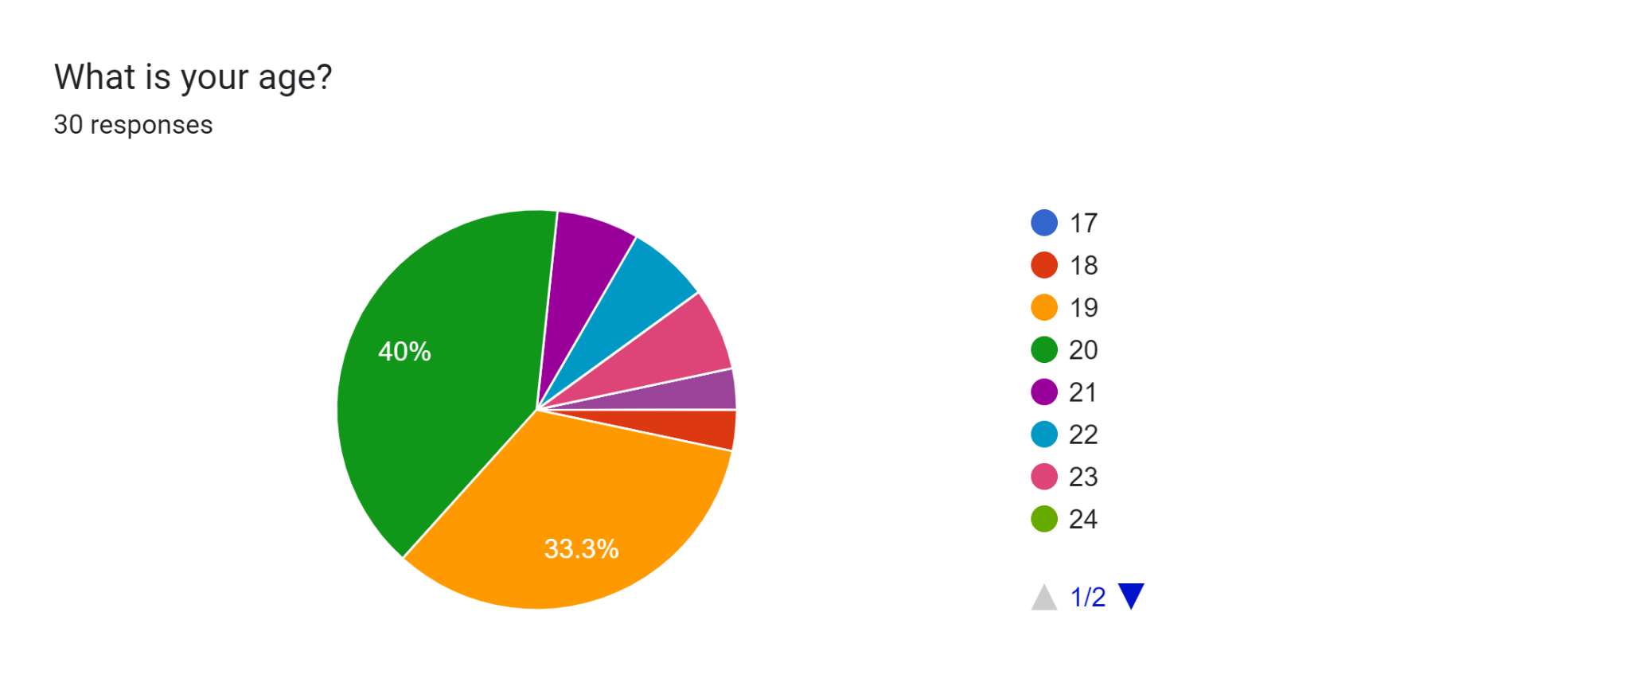

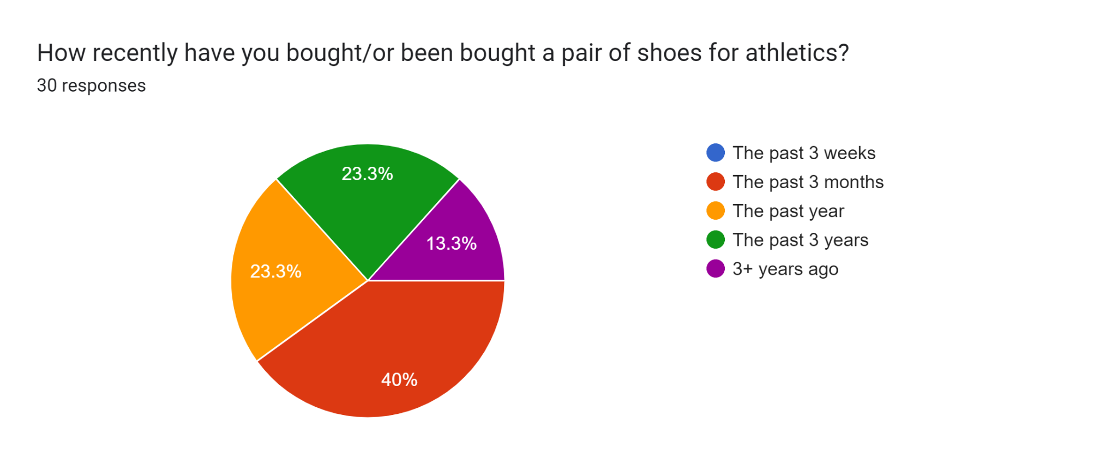

2.2

2.3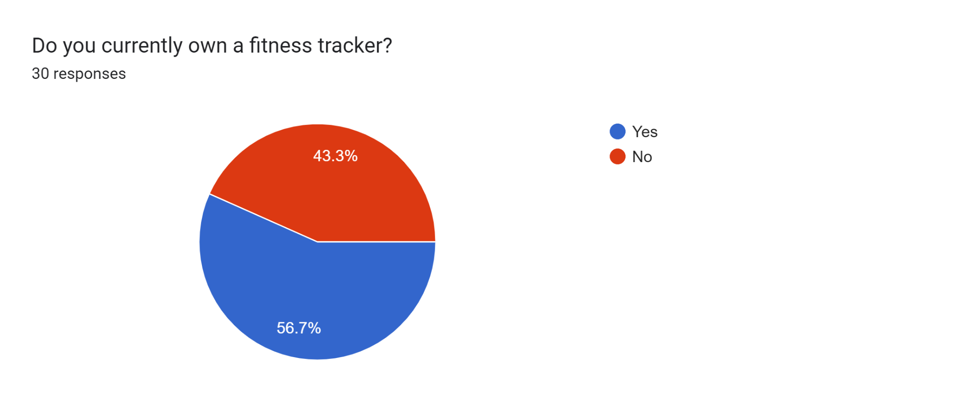

2.4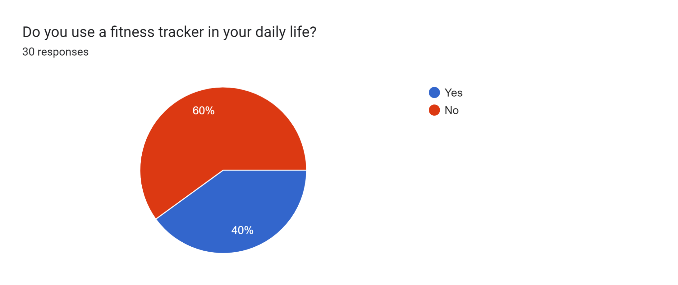

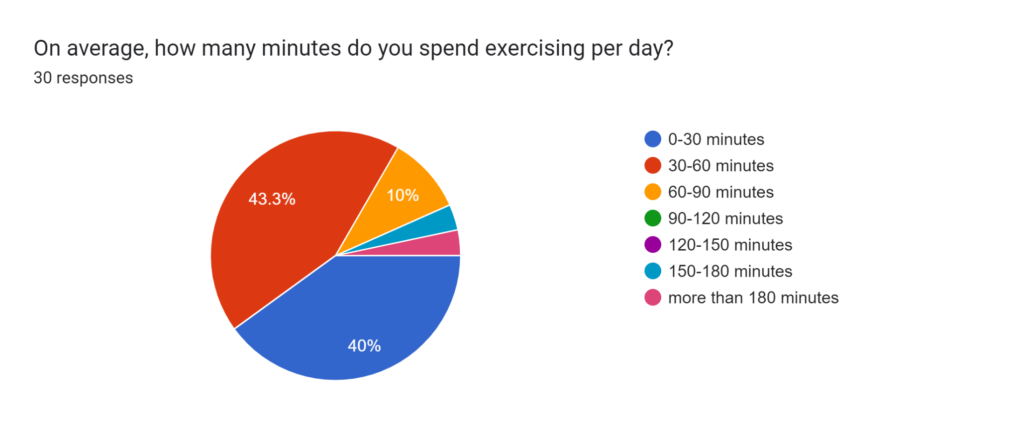

2.5

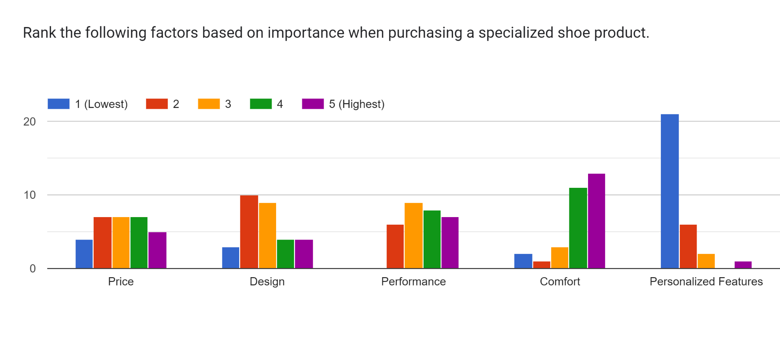

2.6

2.7

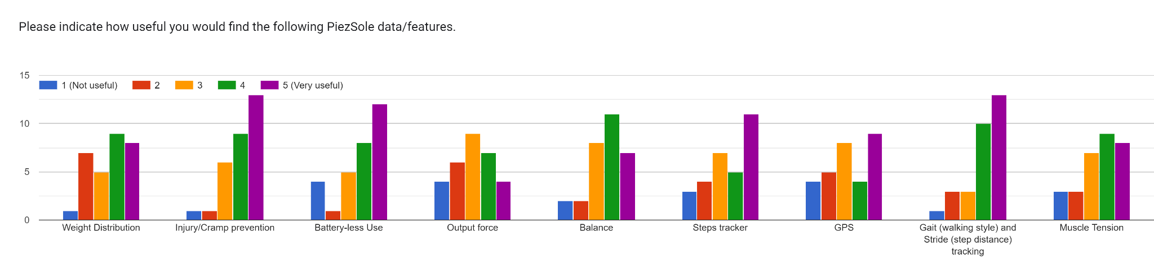

2.8

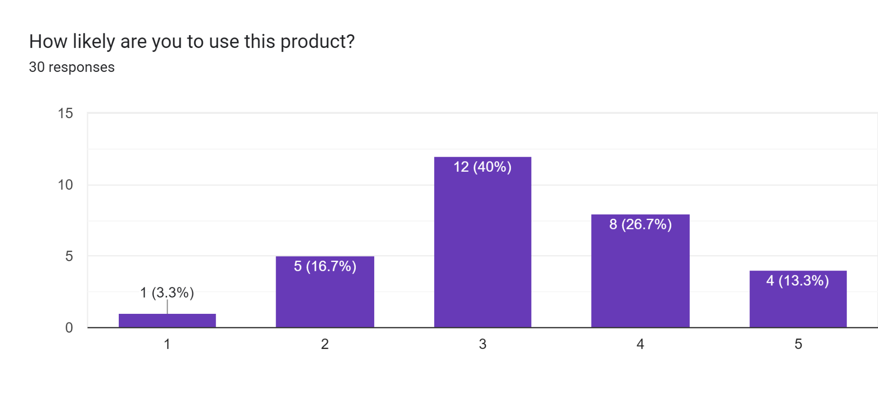

3.1

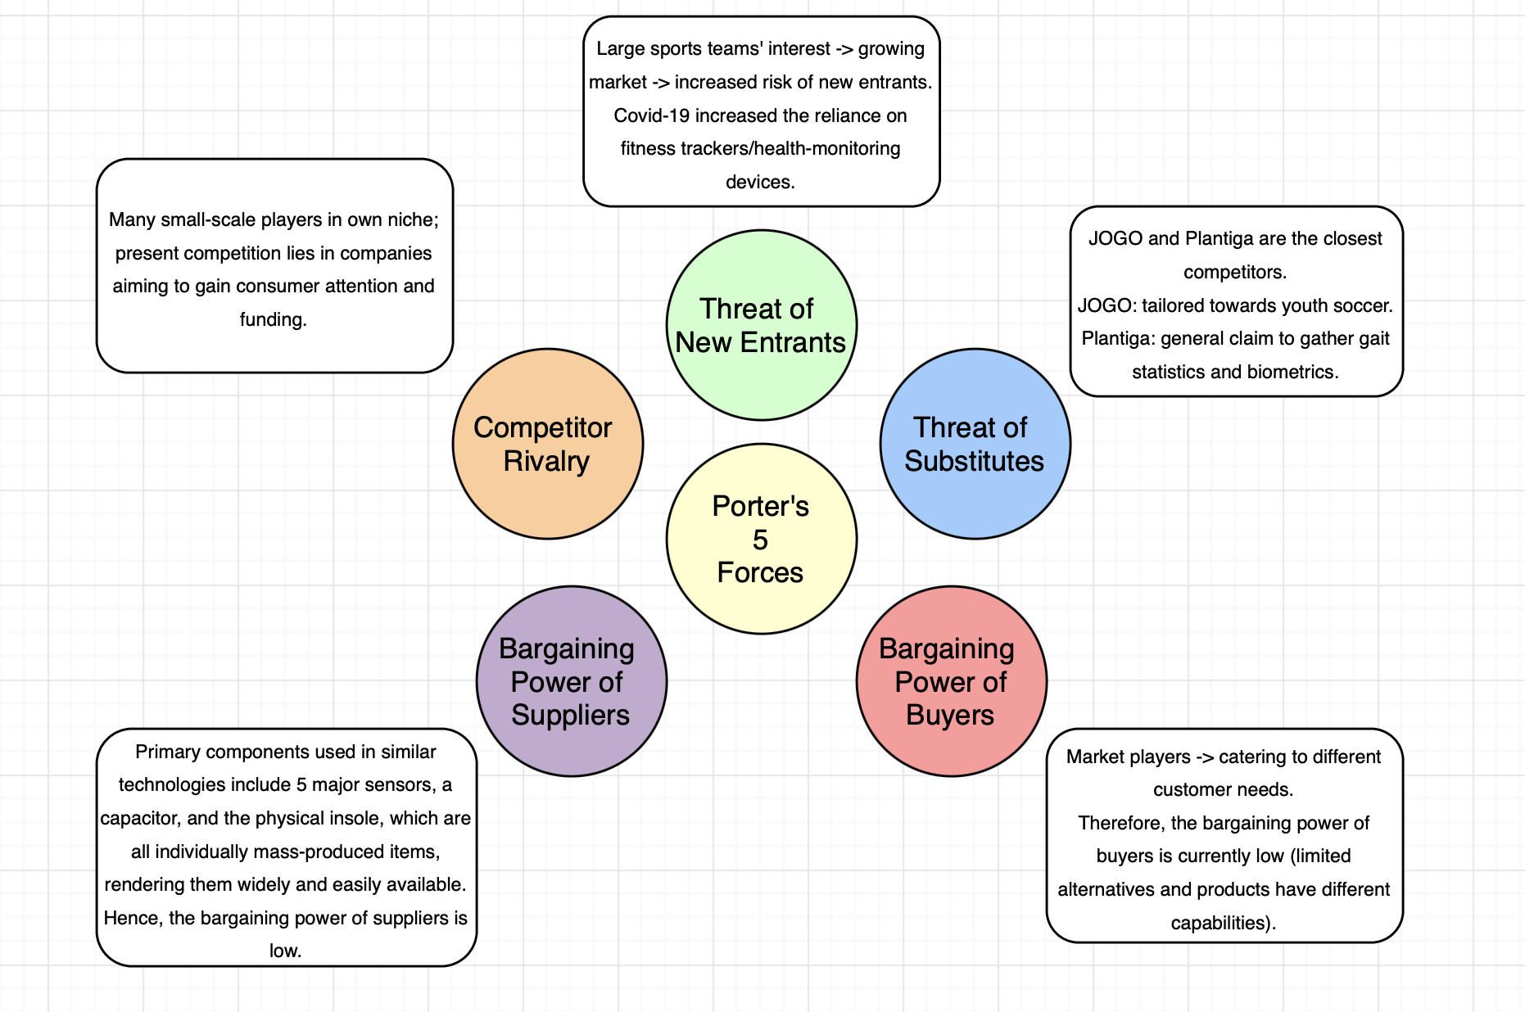

4.1 Piezsole Pricing

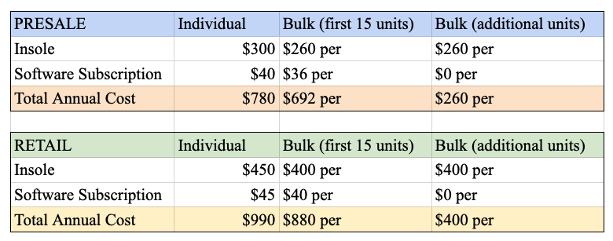

4.2 Financial Calculations

**Margin:**

Margin =

Presale Individual:

Presale Bulk (first 15 units):

Presale Bulk (additional units):

Retail Individual:

Retail Bulk (first 15 units):

Retail Bulk (additional units):

**Break-Even Point**:

BEP:

**n = 1,065 units sold to break even** (5 year customer lifetime)

**Profits and revenues calculated using different market captures**:

BEP:

**30% Market Capture**: n = 0.3 * 5,480 = 1,644

, Profit = $1,357,646

Revenue = = $3,856,824

**40% Market Capture**: n = 0.4 * 5,480 = 2,192

, Profits = $2,643,528

Revenue = = $5,142,432

4.3 Bill of Materials





**References**

*Plantiga - Human Movement Intelligence*, https://plantiga.com/. Accessed 28 September 2022.

Almulla, Jassim, and Abdulrahman Takiddin. “The use of technology in tracking soccer players' health performance: a scoping review - BMC Medical Informatics and Decision Making.” *BMC Medical Informatics and Decision Making*, 11 August 2020, https://bmcmedinformdecismak.biomedcentral.com/articles/10.1186/s12911-020-01156-4. Accessed 28 September 2022.

Chua, Julian. “Wearable Soccer (Football) Sensors That Track Shots, Passes And More.” *Sports Technology Blog*, 1 June 2022, https://sportstechnologyblog.com/2022/06/01/wearable-soccer-football-sensors-that-track-shots-passes-and-more/. Accessed 28 September 2022.

Creasey, Simon. “Wearable technology will up the game for sports data analytics.” *Computer Weekly*, 1 August 2014, https://www.computerweekly.com/feature/Wearable-technology-will-up-the-game-for-sports-data-analytics. Accessed 28 September 2022.

Dowsett, Ben. “The NBA Is Turning To Wearable Sensors To Prevent Player Injuries.” *FiveThirtyEight*, 8 August 2022, https://fivethirtyeight.com/features/the-nba-is-turning-to-wearable-sensors-to-prevent-player-injuries/. Accessed 28 September 2022.

Dowsett, Ben. “The NBA Is Turning To Wearable Sensors To Prevent Player Injuries.” *FiveThirtyEight*, 8 August 2022, https://fivethirtyeight.com/features/the-nba-is-turning-to-wearable-sensors-to-prevent-player-injuries/. Accessed 28 September 2022.

“Energy From Footsteps | Generating electricity by h...” *Leading Edge Only*, https://www.leadingedgeonly.com/innovation/view/energy-from-footsteps. Accessed 28 September 2022.

“FLEX PCBs.” *PCB Universe*, http://www.pcbuniverse.com/pcbu-flex-pcb.php. Accessed 28 September 2022.

“Home.” *YouTube*, 5 December 2018, https://www.forbes.com/sites/robertkidd/2021/12/15/soccer-clubs-turn-to-muscle-performance-technology-to-protect-players-from-potential-injury/?sh=4aec6c5649fb. Accessed 28 September 2022.

MAADDI, ROB. “NFL funding study on its most common injury: hamstrings.” *AP News*, 15 July 2021, https://apnews.com/article/sports-science-health-nfl-b80168ce10f9531767c3874b56c50ee5. Accessed 28 September 2022.

“Nextiles Raises $5M in Oversubscribed Seed Round to Fuel Growth in Smart Athletics.” *PR Newswire*, 7 June 2022, https://www.prnewswire.com/news-releases/nextiles-raises-5m-in-oversubscribed-seed-round-to-fuel-growth-in-smart-athletics-301561240.html. Accessed 28 September 2022.

“Plantiga raises $1.2M to launch individual movement health monitoring.” *PR Newswire*, 29 June 2021, https://www.prnewswire.com/news-releases/plantiga-raises-1-2m-to-launch-individual-movement-health-monitoring-301321515.html. Accessed 28 September 2022.

“The Smallest RFID Tag as Thin as Sand.” *rfidhy*, https://www.rfidhy.com/the-smallest-rfid-tag-as-thin-as-sand/. Accessed 28 September 2022.

“Wearable Fitness Trackers Market Size is projected to reach USD 192 Billion by 2030, growing at a CAGR of 17.5%: Straits Research.” *GlobeNewswire*, 26 July 2022, https://www.globenewswire.com/en/news-release/2022/07/26/2486310/0/en/Wearable-Fitness-Trackers-Market-Size-is-projected-to-reach-USD-192-Billion-by-2030-growing-at-a-CAGR-of-17-5-Straits-Research.html. Accessed 28 September 2022.

“ZOE-M8B module | u-blox.” *U-blox*, https://www.u-blox.com/en/product/zoe-m8b-module. Accessed 28 September 2022.

"Physical Therapists in the US - Industry Market Research Report." IBISWorld, IBISWorld, Inc., 2021, www.ibisworld.com/united-states/market-research-reports/physical-therapists-industry/. Accessed 28 September 2022.